|  |  |
| --- | --- |
| *Pacific Gas and Electric Company* | |
| Patch 7.5.8 Installation Guide | |
|  |  |
|  |  |
| Project | ED AM/GIS |
|  |  |
| Prepared by | Ashish Narasimham |
| Date | 8/7/2013 |
| Version | 1.1 |
| Version Type | Final |

|  |  |  |  |
| --- | --- | --- | --- |
| Revision History | | | |
| Document # | Date | Author | Summary of Changes |
| 1.0 | 8/7/2013 | Ashish Narasimham | Initial Document Creation |
| 1.1 | 8/8/2013 | Ashish Narasimham | Added CR9330 |

# Introduction

## Purpose

This document is intended to detail the implementation and configuration steps required to implement the Patch 7.5.8 Installation Guide. This document describes the various configuration aspects required to complete any manual or automatic patch associated with this release. Each section in this document contains the steps required to patch the system in production.

## Terms Used

|  |  |
| --- | --- |
| OOTB | Out of the box. Unmodified from the commercial version. |
| TFS | Team Foundation Server |

## External Documents

Referenced are any external configuration documents or exports. These are documents that contain more detailed information about configuring a system or documents that can be loaded into an application to perform the configuration detailed in this document.

## Summary of Steps to Complete Patch

These are the high-level steps to complete the installation and configuration of the data model patch. Use this table as a guide for completing the installation. Links are provided that can lead either within the document for detailed explanations or to external sites such as Sharepoint.

|  |  |  |  |
| --- | --- | --- | --- |
|  | **Step Name** | **Description** | **CR (if applicable)** |
|  | Master For Data Model Release 7.5.8 | Master for data model release 7.5.8, all related tickets are linked | [9303](http://edappgistfsprd1:8080/tfs/ElectricDistCollection/EDAMGIS/_workItems#_a=edit&id=9303) |
|  | Open a Database Connection | Open a database connection in ArcCatalog | - |
|  | Conduit System : DuctsVacant, DuctsFilled | Change domain properties on these fields | [9288](http://edappgistfsprd1:8080/tfs/ElectricDistCollection/EDAMGIS/_workItems#_a=edit&id=9288) |
|  | Change Step Down Default annotation class | Change label expression and SQL query on Default class | [9290](http://edappgistfsprd1:8080/tfs/ElectricDistCollection/EDAMGIS/_workItems#_a=edit&id=9290) |
|  | Correct Fault Indicator Annotation expression | Edit label expression for FaultIndicatorAnno | [9292](http://edappgistfsprd1:8080/tfs/ElectricDistCollection/EDAMGIS/_workItems#_a=edit&id=9292) |
|  | Change Transformerdevice alias | Change alias on table | [9299](http://edappgistfsprd1:8080/tfs/ElectricDistCollection/EDAMGIS/_workItems#_a=edit&id=9299) |
|  | Remove "0-Division Boundary" Domain Value from Division Name domain | Remove value from domain | [9330](http://edappgistfsprd1/sites/ElectricDistCollection/EDAMGIS/_layouts/tswa/UI/Pages/WorkItems/WorkItemEdit.aspx?id=9330&tfs=http%3A%2F%2Fedappgistfsprd1%3A8080%2Ftfs&pcname=ElectricDistCollection) |
|  | Update Data Model Version Table | Update the data model version table to reflect this update | - |

# Open a Database Connection in ArcCatalog

1. Open ArcCatalog.
2. Within the Catalog Tree, expand “Database Connections” and open the active connection for this process. This is the connection that is referenced in the change request associated with this document (EDGIS<DB name in the format X#Y> )

# Conduit System: DuctsVacant, DuctsFilled

1. 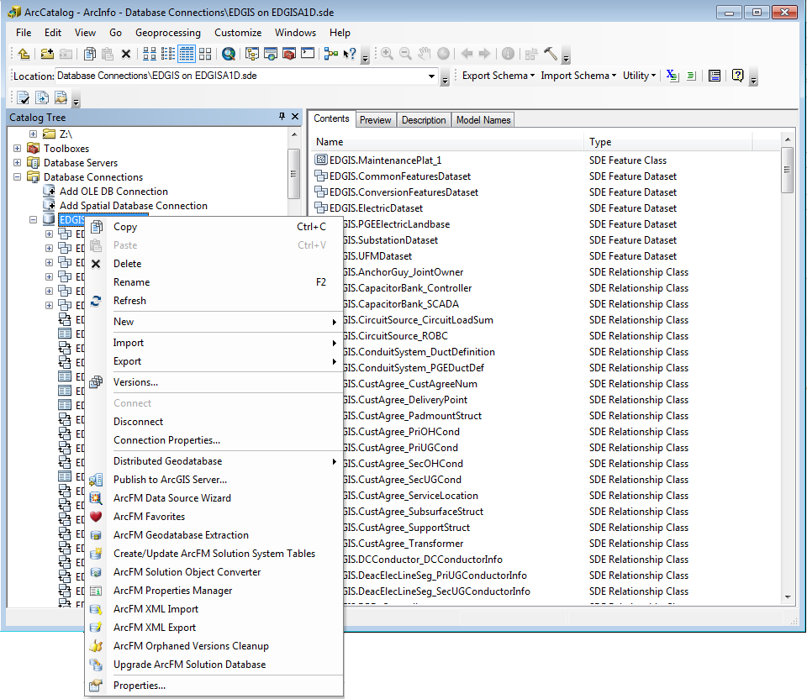Right click the database connection and click ‘Properties’.
2. Click the ‘Domains’ tab and navigate to the ‘Duct’ domain. Select this domain.
3. Change the minimum value to ‘0’ and the maximum value to ‘50’.  
   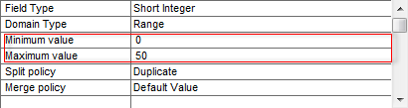
4. Click ‘Apply’ and ‘OK’.

# Change StepDown Default annotation class

1. Expand the ElectricDataset, right click the StepdownAnno feature class, and click ‘Properties’.  
   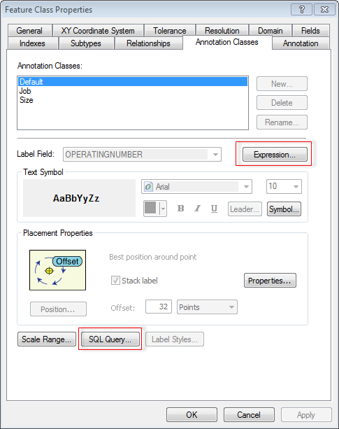
2. Click the  button next to ‘Label Field:’.
3. Uncheck the  check box.
4. Set the value of the ‘Expression’ text area to:

[OPERATINGNUMBER]

1. Click ‘OK’.
2. Click the  button near the bottom of the window.
3. Set the value of the query text area to:

OPERATINGNUMBER is not null

1. Click ‘OK’ and ‘OK’ again to apply all changes.

# Correct Fault Indicator Annotation expression

1. Expand the ElectricDataset, navigate to the FaultIndicatorAnno feature class, right click it, and select ‘Properties’.  
   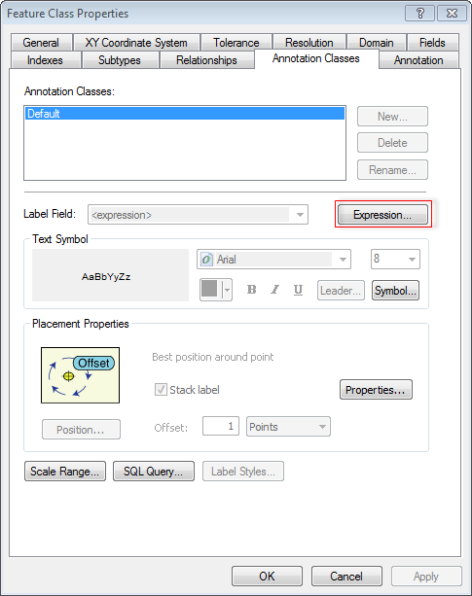
2. Select the  button next to the ‘Label Field:’ text.

Function FindLabel ( [SubtypeCD], [FIType] )

If [SubtypeCD] = "Fault Indicator" and [FIType] = "Manual Reset" then  
    FindLabel = "M"  
end if

End Function

1. In the text area for ‘Expression’, replace the current contents with the following text:
2. Click ‘OK’ and ‘OK’ again to apply all changes.

# Change Transformerdevice alias

1. 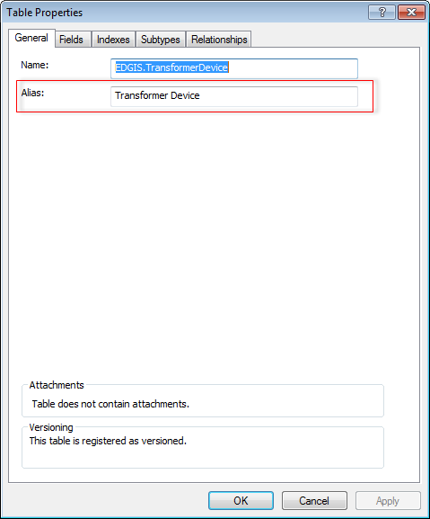Scroll to the TransformerDevice table at the root level, right click it, and select ‘Properties’.
2. Locate the ‘Alias:’ text box, and change the text to ‘Transformer Device’.
3. Click ‘OK’.

# Remove "0-Division Boundary" Domain Value from Division Name domain

1. Right click on the database connection and click ‘Properties’.
2. Click the ‘Domains’ tab, scroll down to the ‘Division Name’ domain, and click the domain.
3. In the list of domain codes/values, locate the entry with code: 0 and value: Division Boundary.
4. Highlight the row and press Delete on your keyboard to delete the entry.  
   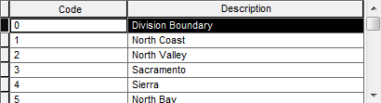
5. Click ‘OK’.

# Update Data Model Version Table

**Database Configuration:**

1. Open SQL Plus.
2. Log in using the same server and user as was used in section 2.  
     
   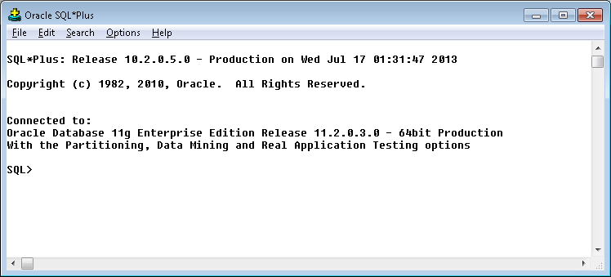
3. Run the SQL below:

update pgedatamodelversion set currentidc='N' where currentidc='Y';

insert into pgedatamodelversion (OBJECTID, CURRENTIDC, DATEAPPLIED, APPLIEDBYPERSONNAME, MODELVERSION) values (**31**,'Y',sysdate,'**<INSERT TEAM MEMBER DONE BY>**','**7.5.8** GOLD **CR9303**');

# Known Issues

<Please List any other issues encountered here while following the document>